zaglavlje

LOGO WILL BE HERE

A MODEL OF ACC - ADAPTIVE CRUISE CONTROL

Kustura Melisa[1], Kostić Aleksandra[2]

**Summary:**. Currently on the market there is no vehicle in which the intelligent transportation systems (ITS) have not found application. One of the most developed ITS lately is the Adaptive Cruise Control (ACC). The ACC is a new technology which requires the use of sensors for detecting the velocity and distance of the vehicle in front of a vehicle equipped with the ACC system and enables ACC vehicle to adjust its velocity accordingly. In this paper we have developed an ACC model. Also, we have analyzed the results obtained by its simulation. The MATLAB program is used to calculate the values ACC model needs in order to operate. We present a physical and mathematical model as well as the simulation results in the form of diagrams.

Key words: Intelligent Transport Systems; Adaptive Cruise Control; new technologies

1. INTRODUCTION

ACC system has a duty to maintain a constant, predetermined velocity, but also to monitor the velocity of the vehicle located in front of the ACC vehicle. Also, ACC represents the evolution of the conventional cruise control, because it detects the vehicle in front of the ACC vehicle, and based on gained information controls the distance between both vehicles. In this way, the ACC system facilitates the process of driving for drivers and reduces the stress caused by driving in heavy traffic. Based on data of the velocity and the distance of vehicles located in front of the ACC vehicle, the system regulates the braking force of the ACC vehicle and its engine torque, and determines the velocity of the ACC vehicle, which is necessary to maintain safe distance in the traffic. Because of this ACC system was the subject of research in the literature [1,3,4,5].

The master thesis [5] of the first author gives an overview of the intelligent transportation systems with a focus on the ACC system. In this paper we present a model of the ACC system. The paper considers the physical and mathematical model in Section 2, MATLAB program and the results of simulations in the form of a diagram are presented in Section 3. In Section 4 we give conclusion and present future research.

1. MODELING DYNAMICS OF A VEHICLE EQUIPPED WITH THE ACC SYSTEM

If the vehicle is detected by a sensor in the traffic lane in front of the ACC vehicle, ACC vehicle will slow down to the same velocity and will maintain an appropriate distance from the vehicle in front until it leavs the traffic lane, as shown in Figure 1.

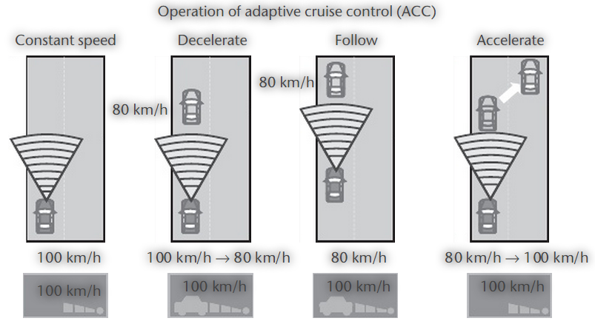

Fig. 1 A vehicle equipped with ACC system monitors the vehicle located in front of it

To enable described motion of the ACC vehicle, it is necessary to mathematically describe the movement of the ACC vehicle, and set up a matching algorithm that will allow the operation of the ACC system with the given initial conditions. We can conclude that the basic control parameter for the operation of the ACC system is velocity $v_{1}$ of the vehicle in front of ACC vehicle, and the distance between the vehicles $d$. In this paper we present the case of movement of two vehicles, provided that the second vehicle is equipped with the ACC system.

As seen in Figure 1 the vehicle 2 is equipped with ACC system and is tasked to monitor the vehicle 1 located in front of it at a given distance. If vehicle 1 accelerates, the ACC vehicle 2 will accelerate until it reaches the given initial velocity which it had before encountering an obstacle or the vehicle in front. To achieve the referral, already explained movement, it is necessary to mathematically describe the movement of a vehicle equipped with the ACC system, and set up a matching algorithm that will allow the operation of the ACC system with the given initial conditions.

In the case of linear movement of the ACC vehicle on a flat surface, it is necessary to achieve a balance of forces acting in the direction of the vehicle, which by convention corresponds the x coordinate. Such movement can be described as

|  |  |
| --- | --- |
| $$\sum{F_{x}=0}$$ | (1) |

where $F_{x}$ represents forces acting in the direction of x coordinate. Previous equation in a developed form can be written as follows

|  |  |
| --- | --- |
| $$F_{o}=R_{f}+R_{j}+R_{v}$$ | (2) |

where $F_{o}$ is circumferential force to a point, $R_{f}$ is rolling resistance, $R_{j}$ is resistance of inertial forces when decelerating and $R_{v}$ is air resistance. In order to achieve greater quality regarding the work of the ACC vehicle, it is necessary to control the velocity of ACC vehicle ${(v}_{2})$.This velocity control is based on the velocity of the vehicle in front ${(v}_{1})$, as well as the parameter of the distance between vehicles $(d)$. The distance parameter is further controlled and kept constant when the vehicles are located at a given distance. In case that during the constant velocity of ACC vehicle occurs decrease of the distance from the vehicle in front, which is moving, it is necessary to perform braking of the ACC vehicle. In this way the velocity of the ACC vehicle is reduced to the velocity of vehicle 1 which is moving in front of it. By doing so the contact (collision) between the vehicles is avoided.

The total braking force of the vehicle can be determined from the condition of equality of all horizontal forces. Therefore, the equation of motion of the ACC vehicle takes shape

|  |  |
| --- | --- |
| $$F_{K}=R_{j}-R_{f}+R_{v}$$ | (3) |

where $F_{K}$ is breaking force. Also, when breaking, the vehicle velocity decreases continuously, in addition intensity of the generated braking force is much larger than the rolling resistance, so the resistance of the air and the rolling resistance are often ignored (negligible). However, due to the accuracy of braking force calculations in this paper we have taken both of these resistances into account. Braking force is linearized and defined as

|  |  |
| --- | --- |
| $$F_{k}=K·t$$ | (4) |

where $K$ is braking constant and $t$ is time. The breaking force is transmitted differently on front and rear axle for the better usage of the grip between the tiers and the road, because mass of the vehicle is not uniformly placed throughout the vehicle. For this paper considered breaking force is relevant for both axels of the vehicle. The breaking constant $K$ is determined as summation of the braking constant of the front axle $K_{1}$ and the braking constant of the rear axle $K_{2}$.

|  |  |
| --- | --- |
| $${K=K}_{1}+K_{2}.$$ | (5) |

The choice of the constant $K$ is made based on the maximum deceleration that is necessary to make with ACC vehicle in order to decelerate to the velocity of the vehicle in front of it. Maximum deceleration is calculated as follows

|  |  |
| --- | --- |
| $$j_{max}=\frac{v_{2}^{2}-v_{1}^{2}}{2·(R-r)}$$ | ((6) |

where $v_{1}$ is the velocity of the vehicle moving in front of the ACC vehicle, $v_{2}$ is the velocity of the ACC vehicle, $R$ is distance between the vehicles at which the ACC system starts to act, $r$ is minimum distance between the vehicles where ACC stops its functions. For this paper we have chosen braking constants as follows:

* For deceleration larger than $-2\frac{m}{s^{2}}$, the braking constant is $K_{1}=1000\frac{N}{s}$;
* For deceleration in interval $\left(-4\frac{m}{s^{2}}\right.$, $\left.-2\frac{m}{s^{2}}\right]$, the braking constant is $K_{2}=2000\frac{N}{s}$;
* For deceleration in interval $\left(-6\frac{m}{s^{2}}\right.$, $\left.-4\frac{m}{s^{2}}\right]$, the braking constant is $K_{3}=3000\frac{N}{s}$;
* For deceleration in interval $\left(-8\frac{m}{s^{2}}\right.$, $\left.-6\frac{m}{s^{2}}\right]$, the braking constant is $K_{4}=4000\frac{N}{s}$;
* For deceleration less than or equal $-8\frac{m}{s^{2}}$, the braking constant is $K_{5}=5000\frac{N}{s}$.

In case of using maximum braking force of the ACC vehicle with maximum grip taken in account, the maximum braking force is

|  |  |
| --- | --- |
| $$F_{kmax}=m·j_{max}=m·g·φ_{max}$$ | (7) |

where $j_{max}$ is maximum vehicle deceleration, $φ_{max}$ is maximum coefficient of adhesion and $g$ is gravity acceleration.The resistance of inertial forces is given as

|  |  |
| --- | --- |
| $$R_{j}=m·j$$ | (8) |

where $j$ is vehicle deceleration and $m$ is mass of the vehicle. The rolling resistance is defined by the equation

|  |  |
| --- | --- |
| $$R_{f}=m·g·f$$ | ((9) |

where $f$ is coefficient of rolling resistance. The coefficient of rolling resistance is determined by the empirical expression for the radial tire, which reads

|  |  |
| --- | --- |
| $$f=f_{0}+f_{1}·v+f_{4}{·v}^{4}$$ | (10) |

where $f_{0},f_{1},f_{4}$ are empirically derived constants, where $f_{0}=9,91{·10}^{-3},{ f}_{1}=1,95{·10}^{-5},$ $f_{4}=1,76{·10}^{-9}$. [2] Air resistance is calculated according to the formula

|  |  |
| --- | --- |
| $$R_{v}=\frac{1}{2}{·c}_{x}·A·ρ·v^{2}$$ | ((11) |

where $c_{x}$ is drag coefficient, $A$ is frontal area of the vehicle and $ρ$ is air density. Deceleration of the vehicle is defined as

|  |  |
| --- | --- |
| $$j=\frac{F_{K}+R_{f}+R_{v}}{m}.$$ | ((12) |

Velocity of both vehicles is calculated according to $v=v_{0}-\int{j}dt$ where $v_{0}$ is initial velocity of the vehicle. For calculating the traveled distance of the ACC vehicle the following equation is used $s=s_{0}+\int{v}dt$ where $s_{0}$ is the initial distance betveen the vehicles. To determine traveled distance of the ACC vehicle and vehicle in front of it is necessary to calculate the integral of their corresponding velocitys. Also, the velocity of the vehicle in front of the ACC vehicle can be constant or variable. Distance between the vehicles is

|  |  |
| --- | --- |
| $$d=s_{1}{-s}_{2}$$ | (13) |

where $s_{1}$ is the traveled distance of the first vehicle and $s_{2}$ is travelled distance of the ACC vehicle, the second vehicle.

1. THE ANALYSIS OF RESULTS OBTAINED BY USING THE ACC MODEL

To test our ACC model we have considered the influence of the changes in the relative velocity between vehicles when the second vehicle is equipped with the ACC system. The influence of changes in the relative velocity between the vehicles shows how the second vehicle (ACC vehicle) behaves when the initial velocity of the first and the second vehicle is different. Distance between vehicles remains unchanged, as all other parameters relevant to the work of the ACC system. Initial conditions are given in

Table 1 Initial conditions for the ACC simulation and their notation

|  |  |
| --- | --- |
| **Notaton and value** | **Explanation** |
| $v_{02}=100 \frac{km}{h}$*.* | The initial velocity of the vehicle with the ACC system |
| $$t=10s$$ | Simulation time |
| $${ m}_{2}= 1600 kg$$ | Mass of the ACC vehicle with the driver |
| $${ c}_{x}=0,29$$ | Drag coefficient |
| $$A=2,02 m^{2}$$ | The front surface of the ACC vehicle |

We considered motion of the vehicle on the wet asphalt which can also be concluded from the choice of the maximum coefficient of adhesion. In our numerical experiment we considered three cases. The first case is given with $v_{01}=90 \frac{km}{h}$, the second one is given with $v_{01}=80 \frac{km}{h}$ and the thired is given with $v_{01}=70 \frac{km}{h}$. In all three cases $R=100 m, r=25 m,{ d}_{0}=120m$  
.

The following MATLAB program is used for the ACC model simulation:

function [v2,d,j,Fk]=ACC3k(R,r,v01,v02,S0,vrijeme,m2,Cx,A)

v01=(10*v01)/36; v02=(10*v02)/36;

v2=zeros(vrijeme*10+1,1; d=zeros(vrijeme*10+1,1);

j=zeros(vrijeme*10+1,1; Fk=zeros(vrijeme*10+1,1);

T=zeros(vrijeme*10+1,1);

f0=9.91*10^-3; f1=1.95*10^-5;f2=1.76*10^-9;

s1=0;s2=0;ACCA=0;v2(1)=v02;d(1)=S0;j(1)=0;

S1=S0;i=1;T(1)=0;j(1)=0;a=(v02^2-v01^2)/(R-r); a=a/2

if a<2

faktor=1000

elseif (a>=2)&(a<4)

faktor=2000

else if (a>=4)&(a<6)

faktor=3000

elseif (a>=6)&(a<8)

faktor=4000

else a>=8

faktor=5000

end

end

for t=0.1:0.1:vrijeme

i=i+1;T(i)=t;s1=s1+v01*0.1;S1=S1+v01*0.1;

if d(i-1)>R

ACCA=0;v2(i)=v02;

else

if v2(i-1)>v01

ACCA=1; Fk(i)=Fk(i-1)+ACCA*faktor*0.1;

if Fk(i)>8228.57

Fk(i)=Fk(i-1)

end

f=f0+f1*v2(i-1)+f2*v2(i-1)^4;

Rf=m2*9.81*f; Rv=0.5*1.25*Cx*A*v2(i-1)^2; Rj=Fk(i)+Rf+Rv;

j(i)=Rj/m2; v2(i)=v2(i-1)-j(i)*0.1;

if v2(i)<v01

v2(i)=v01

end

else

v2(i)=v01; ACCA=0;

end

end

s2=s2+v2(i)*0.1; S2=s2; d(i)=S1-S2;

end

plot(T,v2*3.6,'r')

Obtained results are given in Figure 2.

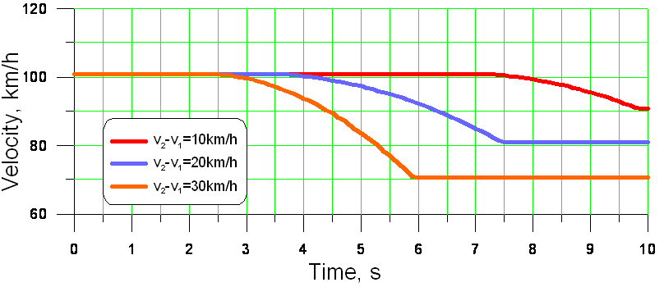

Fig. 2 *Velocity diagram of the vehicle equipped with the ACC system in our three cases*

From Figure 2 can be seen that the greatest change in velocity occurs when the velocity difference is 30 km/h, and the smallest change when the velocity difference is 10 km/h, which was expected. The beginning of the velocity change is different, because the vehicle needs less time to reach the velocity of the first vehicle if the velocity difference between the first and the second vehicle is smaller.

1. CONCLUSION

After examining the results it can be concluded that this model, which simulates the operation of the ACC system, is very good in terms of velocity equalization between the first and second vehicle (ACC vehicle). Also, when it comes to velocity equalization distance between the vehicles remains constant, which again points to the model of good quality. When the velocity of the vehicles is equal distance between the vehicles remains constant, but it cannot be pre-specified. Distance between the vehicles depends on the velocity difference and initial distance between the vehicles at which ACC system starts to act. The next step in further development of this model would be its optimization, which would result in maintaining a constant velocity on a precise pre-given distance from the first vehicle.

REFERENCES

[1] Bishop, R. (2005). *Intelligent Vehicle Technology and Trends*. Artech House, Norwood.

[2] Dacić S., Trobradović M., Pikula B. (2008). *Fundamentals of Vehicle Dynamics- With Mathematical Problems.* Faculty of Mechanical Engeneering, Sarajevo.

[3] Meyer G., Valldorf J., Gessner W.(2003) *Advanced Microsystems for Automotive Appications-Smart Systems for Safety, Sustainability and Comfort.* Springer Dordrecht Heidelberg, London, New York.

[4] Acarman, T., Liu, Y., Ozguner, U.(2006). Intelligent Cruise Control Stop and Go with and without Communication., *Proceedings of the 2006 American Control Conference*, p. 4356-4357.

[5] Kustura M. (2011). *Application of Intelligent Transportation Systems (ITS) in Modern Motor Vehicles.* Faculty of Mechanical Engeneering, Sarajevo.

1. Melisa Kustura, MA engineer of mechanics, School of Mechanical Engineering (kustura.melisa@gmail.com)

   2 prof .dr., Aleksandra Kostic, Sarajevo, Faculty of Mechanical Engineering, (kostic@mef.unsa.ba)
2.